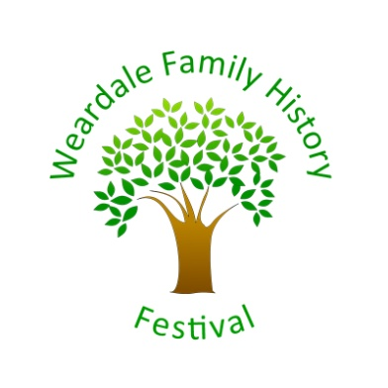

Weardale Family History Festival 1 - 9 July 2017
St Thomas's Church, Market Square, Stanhope, Co. Durham DL13 2UN

An exhibition and series of talks celebrating the rich and detailed family history of Weardale is being hosted by St Thomas's Church, in partnership with the Weardale Museum.

Speakers will cover a number of topics looking at the lives and times of this beautiful rural area where many families are inter-connected. Topics include: Getting Started in Family History, Emigration from Weardale and Research your Local War Memorial
A full programme will be available on the church website: www.stthomasstanhope.co.uk/events.html

The Festival will be opened by Mr Mike Amos at 11am on Sat 1 July.

An exhibition in the church will be open from 10.00 to 17.00 2nd to 9th July. There will be 'experts' available to help with family history queries from 11.00 until 16.00 each day.

Free Admission Refreshments on sale

Accessibility
There are steps up onto the church path from the street and also into the church, ramps are available for wheelchair access. Accessible toilet available in the church.
Large print versions of programme available.

Any queries can be made to Sarah Haynes tel: 01388 528673

Weardale Family History Festival

